RAJEEV KUMAR

**B.TECH-ME**

Phone: +91-9634122280

Email: rajeevkumar61012@gmail.com

Haridwar - 249404, Uttarakhand, INDIA

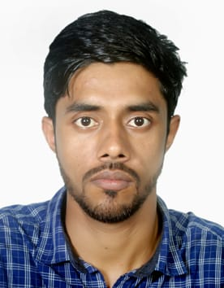

## CAREER OBJECTIVE

Self-motivated and hardworking fresher seeking for an opportunity to work in a challenging environment to prove my coding skills and utilize my knowledge of various databases in the growth of the organization.

**KEY EXPERTISE / SKILLS**

AutoCAD design, Solid Work, Basic Knowledge of CNC Machine

**EDUCATION**

**Gurukul Kangri Vishwavidyalaya**

**B.Tech. - ME** | CGPA: 7.18 / 10.00

[1st-6.8, 2nd-7.31, 3rd-7.33, 4th-6.76, 5th-7.38, 6th-7.50]

**Deepak Pathak Sarvoday Senior Secondary School, Gaya**

**12th** | BSEB | Percentage: 57.40 / 100.00

**High School Bharaundha, Gaya**

**10th** | BSEB | Percentage: 70.20 / 100.00

**PROJECTS**

* Modification Of Microwave Reactor to produce biodiesel.

**ASSESSMENTS / CERTIFICATIONS**

* **Vocational Training at BHEL Haridwar**

General Awareness of Steam Turbine Manufacturing (TUM-BL,3)

* **Workshop on Robotics and Automation**

**PERSONAL INTERESTS / HOBBIES**

Playing Cricket, Listening to music

**PERSONAL DETAILS**

**Gender:** Male

**Marital Status**: Unmarried

**Current Address:** HN.308,near A to Z Automobile, Adarsh Nagar, Roorkee

**Date of Birth:** Aug. 04, 1997

**Phone Numbers:** +91-8630312823

**Emails:** rajeevkumar61012@gmail.com